Abstract Title (capitalize only the first letters of all words except for coordinating conjunctions, articles, and prepositions; avoid non-standard abbreviations; Times New Roman 14 point Bold, multiple 1,15 line spacing, centered)
First Author¹, Second Author², Third Author^{1,*} (please indicate first name, middle initial and last name; the presenting author should be underlined if multiple authors; the corresponding author should be marked with *; degrees and titles must be omitted; Times New Roman 12 point, multiple 1,15 line spacing, centered)
¹ Institution Name, Department, Address, Country (Times New Roman 12 point Italic, multiple 1,15 line spacing, centered)
², Institution Name, Department , Address, Country (Times New Roman 12 point Italic, multiple 1,15 line spacing, centered)
* Corresponding author: email@xxx.yyy.zz
Thank you for submitting your abstract to the LACP³ 2019. Please prepare the abstract in English over this template in order to ensure that all contributions have the same style in the book of abstracts. Text must be written in Times New Roman 11 points, multiple 1,15 line spacing, justified, first line indented 1 cm. Avoid modifying the spacing before and after each paragraph established in this template. The complete document should not exceed two (2) pages for both oral and poster presentations.
Separated paragraphs with introduction, experimental, results and discussion, and conclusions are suggested. However, headings in the text as well as blank lines between the paragraphs are not required.
Figures or tables can be added within the appropriate size and placed at the position considered by the author(s) (centered, right or left aligned, with or without text around). Please insert figures, graphics, schemes and equations as images (.tif, .jpg or .jpeg format) to avoid possible problems with special characters or chemical formulas.
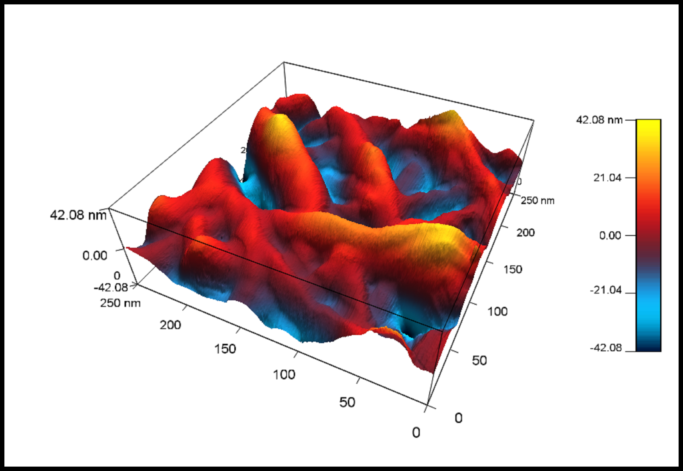
Figure 1. Title (Times New Roman 10 points).
If tables are included please use the following design.
Table 1. Title (Times New Roman 10 points)¹
Times | New | Roman | 10 points | Bold
Times | New | Roman | 10 points
Times | New | Roman | 10 points
¹ Footnote text if needed (Times New Roman 9 points).
References should be sequentially numbered in the text and indicated in square brackets before puncture signs (e.g., “…photocatalysis [1,2].”; “…as shown by other authors [1-3],…”). Please use the Science and Engineering Journal Abbreviations and the bibliography styles shown below in the reference section.
Please save the file with the Thematic Area-Name Surname of presenting author-Number of the abstract submitted by the same presenting author (e.g. Photocatalysis-Andres Suarez-1, Photochemistry-Ana Rozo-2). docx file should be submitted to lacp3@utadeo.edu.co

Each registered author can submit up to two (2) abstracts as presenting author. The presentation of any additional contribution by the same presenting author will cost half of the registration fee.
Acknowledgements
The acknowledgements should be written here in Times New Roman 10 points. Thank you for spending your time following the instructions. Feel free to contact us for any further information.
References:
- J. van der Geer, J.A.J. Hanraads, R.A. Lupton, J. Sci. Commun. 163 (2000) 51-59.
- W. Strunk Jr., E.B. White, The Elements of Style, third ed., Macmillan, New York, 1979.
- G.R. Mettam, L.B. Adams, How to prepare an electronic version of your article, in: B.S. Jones, R.Z. Smith (Eds.), Introduction to the Electronic Age, E-Publishing Inc., New York, 1999, pp. 281-304.

