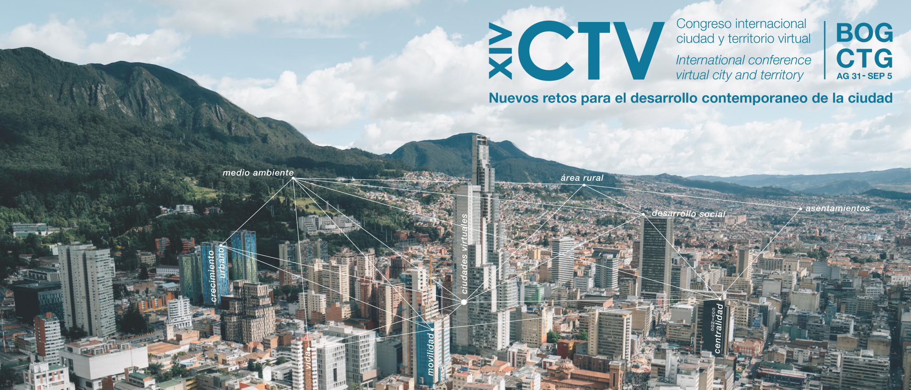

TITLE: IN ARIAL FONT 12 AND BOLDFACE TYPE

Keywords: keyword 1; keyword 2; keyword 3; keyword 4 (minimum three and maximum four).

Thematic panel: Indicate one (1) among the eight (8) thematic panels of the Congress.

Abstract

Authors should not appear here. All authors must be indicated in OJS, following the following indications; Names, surnames, e-mail, ORCID ID, institution, country, biographical summary (brief) indicating the last academic degree obtained. In addition, the contact author for correspondence should be indicated.

The abstract should contain: objectives of the communication, methodology, data used, development, results and main conclusions. Remember that the length should be between 250 and 300 words

