## ICDHS 13 (Bogotá, 2022) submission guidelines [substitute this line for number of your paper and title, using style ICDHS Title]
Include the topic you are applying to, using ICDHS Heading 1 style
keyword1, keyword2, keyword3, keyword4, keyword5 [substitute this line for up to 5 keywords, using style ICDHS Keywords]
Substitute this text for an abstract (100 words maximum) using style ICDHS Abstract. Official written languages are Spanish or English. All papers accepted will be reproduced as submitted by the authors. Therefore, proofreading is the authors’ responsibility. If your paper is not submitted according to the guidelines, it may not be accepted.
Subtitle level 1 [substitute this line for the first subtitle using style ICDHS Heading 1]
Papers submitted to ICDHS13 must have a minimum of 600 and a maximum of 800 words. The word count includes all text, from title to authors details, plus notes, captions and references: please make sure you do not exceed it. Use style ICDHS Text for the body text. Divide your text in topics: headings may be numbered or not, but they must be clearly differentiated. Please proofread your text carefully. Proposals that do not meet an acceptable language standard will not be accepted.
References, footnotes and quotes [substitute this line for the first subtitle of level 2 (if any) using style ICDHS Heading 2]
Use the style above if you need a second level subtitle.
References within the text should be indicated by author and year, in brackets (Author, 2004). If necessary, pages should be indicated after the year, separated by a colon (Author, 2004: 13-15). Only references mentioned within the text should be listed in the references section.
Footnotes must be inserted at the bottom of the page by using the automatic Word function. To quote an author in the text, use ‘single quotes’. Quotations that exceed three lines should be separated from the body text:
Quotations that exceed three lines should be set apart from the body text. Please use style ICDHS Quote from the Styles menu. Quotations that exceed three lines should be set apart from the body text. Please use style ICDHS Quote from the Styles menu. Quotations that exceed three lines should be set apart from the body text. They should be referenced as stated above. (Author, 2004: 16)
Layout [substitute this line for the second subtitle using style ICDHS Heading 1]
Please use this document as a model for text layout and styles.
Figures [substitute this line for the first subtitle of level 2 (if any) using style ICDHS Heading 2]
If it is necessary, embed low-resolution images into the text. All the Figures included must be mentioned in the text. Add captions to every image (Figure 1).
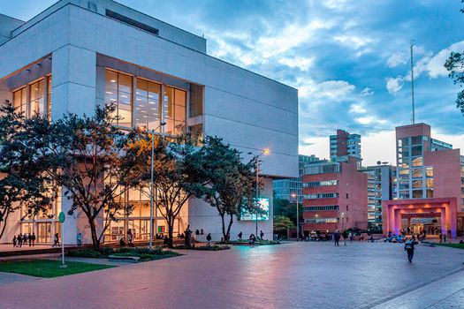
Figure 1. Universidad Jorge Tadeo Lozano.
Be sure to have permission to use the images included in the text, clearing copyright issues before submission.
If your paper includes complex diagrams, tables or graphs, please contact us via e-mail at disenosotros2022@utadeo.edu.co for further guidance and assistance. On March 14th, the Conftool link will be available to upload the proposals.
References
Only references mentioned within the text should be listed in the references section. As a general indication, average number of references is ten. All references mentioned must be alphabetically and chronologically arranged. Examples of how the references should be formatted are given below.
Dean, D. (1994). “A slipware dish by Samuel Malkin: an analysis of vernacular design”. Journal of Design History, 7 (3): 153-167.
Garcés, A. L. (2008). Ojo al aviso: una panorámica de la gráfica, el diseño, el arte y la comunicación visual popular. Quito: La Cajonera.
Martins, F. de O. (2008). Letras que flutuam: o abridor de letra e a tipografia vitoriana. Unpublished monograph, Specialization in Semiotics and Visual Culture, UFPA.
Rojas, L.; Soto, J. (2001). Resumen - Proyecto rescate de tipografias urbano populares chilenas. www.cfurrianca.files.wordpress.com/2008/08/tipografias-chile.pdf (last accessed 09/01/08).
Wogalter, M. S.; Dejoy, D. M.; Laughery, K. R. (1999). “Organizing theoretical framework: a consolidated communication-human information processing (C-Hip) model”. In: Wogalter, M. S.; Dejoy, D. M.; Laughery, K. R. (ed.) Warnings and risk communication: 15-23. London: Taylor & Francis.

About the author(s)
John Smith is Head of the Design Department at the University of City. This text should be replaced by a brief biographical note of around 50 words per author, stating research interests and main publications, ORCID number (optional) and e-mail address. <jsmith@uc.edu>

Example of how your footnotes should be formatted: please choose ICDHS Footnote Text in the Styles menu.

